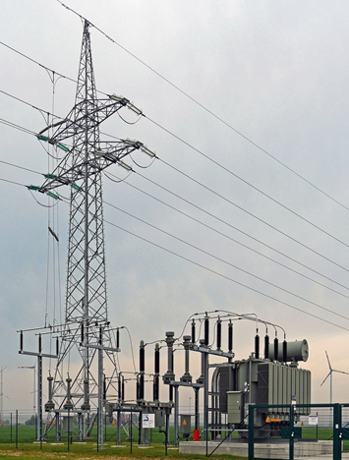

[**VISUAL PHYSICS ONLINE**](http://www.physics.usyd.edu.au/teach_res/hsp/sp/spHome.htm)

**MODULE 6**

**ELECTROMAGNETISM**

**MAGNETIC FIELDS**

**MAGNETIC FLUX**

|  |
| --- |
| **Magnetic field** (B-field ): a region of influence where magnetic materials and electric currents are subjected to a magnetic force. A magnetic field surrounds magnetic materials and current carrying conductors.  Numerous terms are used for the magnetic field and include: magnetic field; magnetic field strength; magnetic flux density; magnetic induction, B-field. All the terms describe the same physical quantity. It is best on most occasions to simply use the term **B-field**.  **Definition of magnetic flux**      **B-field = constant**    **Permanent magnet**    **Current carrying conductor**: direction of B-field given by **right hand screw rule**.    The B-field surrounding a **long straight conductor** carrying a current at a distance  from the conductor    where is a constant called the **permeability of free space**.  Solenoid: Magnetic field of a solenoid is like a bar magnet    bar magnet solenoid  **magnetic field inside a solenoid** |

**MAGNETIC FIELD**

Surrounding a permanent magnetic or a conductor carrying a current there exists a magnetic field .

Numerous terms are used for the magnetic field and include: magnetic field; magnetic field strength; magnetic flux density; magnetic induction, B-field. All the terms describe the same physical quantity. It is best on most occasions to simple use the term **B-field**.

**A field is a region of influence**. For example, a moving charge experiences a force in a magnetic field. A vector field is visualized a pattern of field lines. These lines indicate the field pattern and the density of the lines indicates the strength of the field. The closer the field lines are together, then the stronger the field and hence the stronger the force.

**MAGNETS**

A magnet has a **north pole** and **south pole**. The magnetic field of a magnet can be shown by a set of continuous loops that exit from the north pole of the magnet and enter at the south pole as shown in figure 1, 2 and 3. The B-field lines indicate how a small magnet (or compass) will align itself in the field.

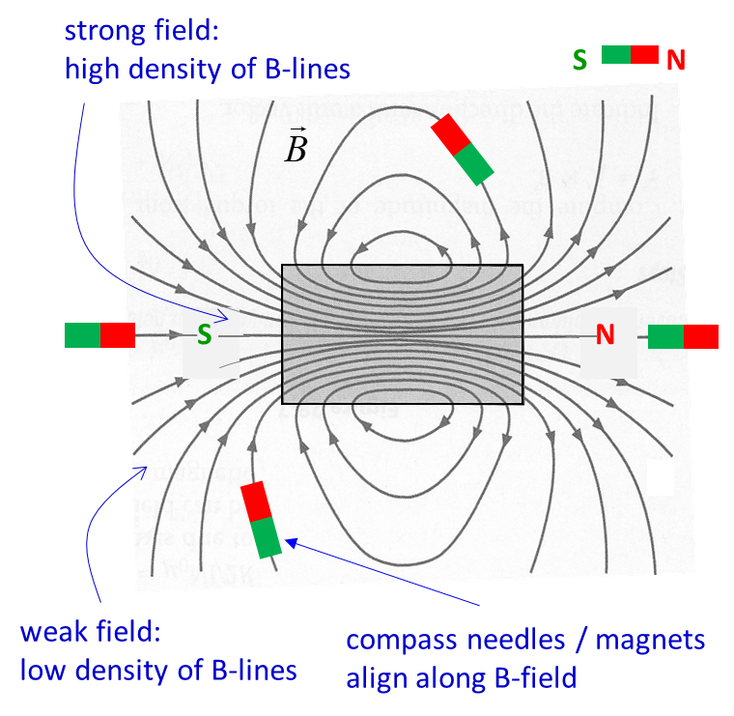

Fig. 1. Magnetic field lines for a bar magnet. The magnetic field lines are continuous loops. The field lines exit away from the north pole and enter the magnet at the south pole. The magnetic field is strongest where the field lines are closest together at the two poles.

[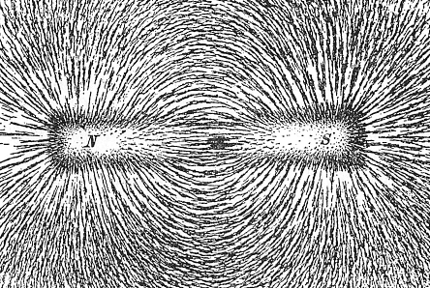](http://upload.wikimedia.org/wikipedia/commons/5/57/Magnet0873.png)[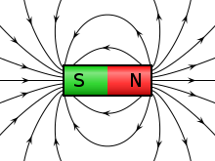](http://upload.wikimedia.org/wikipedia/commons/0/0c/VFPt_cylindrical_magnet_thumb.svg)

Fig. 2. Magnetic field lines for a bar magnet showing the external magnetic field only and the magnetic field pattern due to iron filings. The iron filings align themselves as if they were small magnets and more of them accumulate where the B-field is strongest.

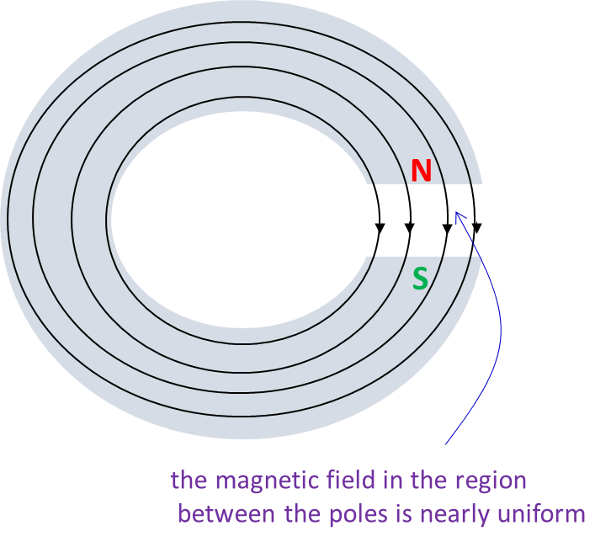

Fig. 3. Magnetic field lines for a horse-shoe magnet. The magnetic field lines are continuous loops. The field lines exit away from the **north pole** and enter the magnet at the **south pole**. The region between the poles is nearly uniform.

**ELECTRIC CURRENTS and MAGNETIC FIELDS**

When electric charges are in motion they exert forces on each other that can’t be explained by Coulomb’s law. If two parallel current carrying conductors attract each other when the currents are in the same direction and repel each other when the currents are in opposite directions. Such forces are called **magnetic forces**.

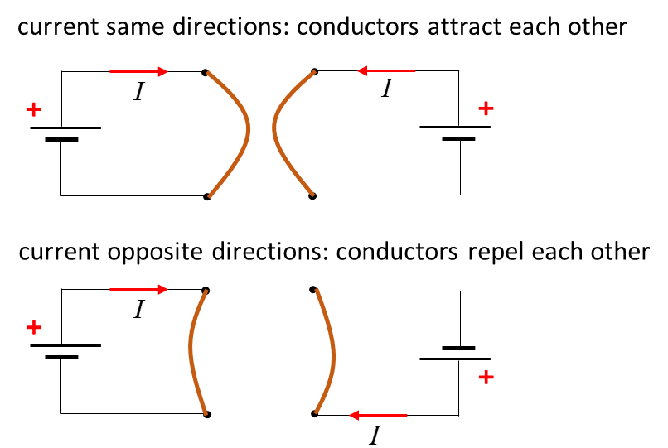

Fig. 4. Magnetic field between two parallel current-carrying conductors.

Hans Oersted (1777 – 1815) placed a wire near a compass needle and switched on the current. When the wire was parallel to the compass needle, the compass needle was deflected by the current. When the wire was perpendicular to the compass needle. There was no deflection when the current was switched on. He made two conclusions: (1) the electric current somehow exerts a twisting force on the magnet near it and (2) the magnitude of the force depends upon the relative orientation of the current and the magnet.

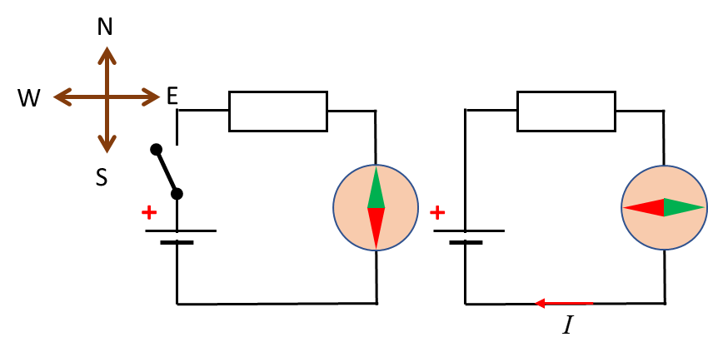

Fig. 5. A compass needle can be deflected by an electric current.

A current (moving charges) through a wire alters the properties of space near it such that a piece of iron will experience a force. Hence, **surrounding a wire carrying a current is a magnetic field**. It is the interaction of the magnetic field and the iron that leads to the force, rather than the current and iron acting upon each other.

The magnetic field surrounding a straight conductor carrying a current  can be visualized as a series of circles. The closer the lines are together, the stronger the magnetic field. A compass placed near the wire will align itself with the field lines. The direction of the magnetic field is determined by the **right-hand screw rule**. Using the right hand: the direction of the thumb represents the current (direction in which positive charges would move) and the curl of the fingers represents the direction of the magnetic field as shown in figure 6. The magnetic field strength is given by the vector quantity where  stands for the **B-field** or **magnetic induction** or **magnetic flux density**. The S.I. unit for the B-field is the **tesla** [T].



Fig. 6. The right-hand screw rule is used to determine the direction of the magnetic field produced by moving charges.

The B-field surrounding a **long straight conductor** carrying a current at a distance  from the conductor is given by equation 1 and as shown in figure 7.

(1)  = 4*π*× 10-7 T.m.A-1

where is a constant called the **permeability of free space**.

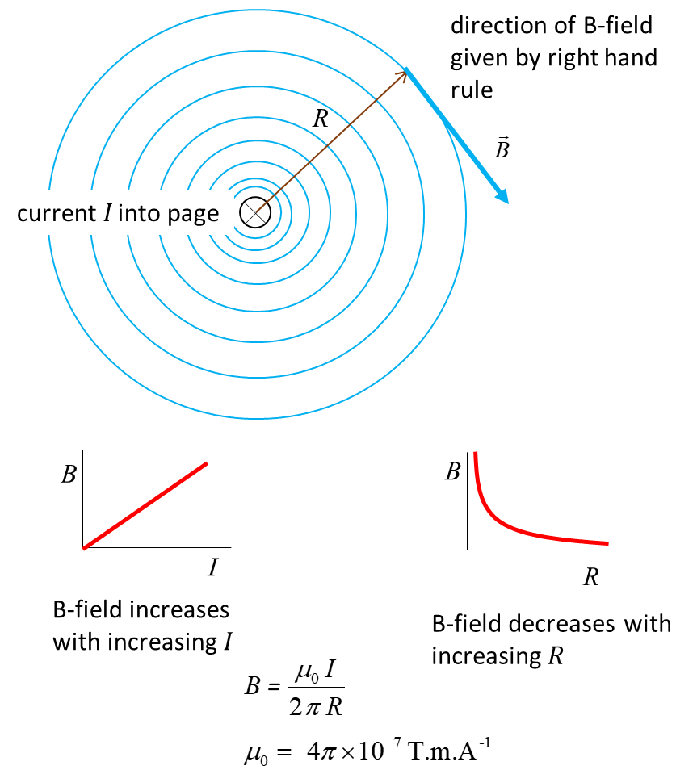

Fig. 7. B-field surrounding long straight conductor carrying a current.

A **circular loop conductor** carrying a current produces a magnetic field like a bar magnet as shown in figure 8.

Fig. 8. Magnet field due to a current loop. The direction of the B-field is given by the right-hand screw rule.

A **solenoid** is a conductor wound into a long set of coils



Solenoids are often used as electromagnets where a ferromagnetic substance placed inside the coils greatly increases the strength of the magnetic field. Figure 9 shows the magnetic field patters for an air-filled solenoid and when a rod of ferromagnetic material is placed inside the coils.



Fig. 9. Magnetic field patterns for a solenoid (air and ferromagnetic cores). A ferromagnetic core greatly enhances the strength of the B-field.

The magnetic field of a solenoid is like that of a bar magnet as shown in figure 10.



Fig. 10. Magnetic field patterns for a bar magnet and solenoid.

For a long solenoid, with closely packed coils, the magnetic field within the solenoid and for the entire cross-section is nearly uniform and parallel to the solenoid axis. For an air filled long solenoid carrying a current  of length  and  number of loops, the magnetic field  inside the solenoid is given by equation 2

(2)  **magnetic field inside a solenoid**

We can define *n* as the number of loops per unit length as



and the magnitude of the B-field can be expressed as

(3) 

The **direction** of the magnetic field inside the solenoid is determined by the right-hand screw.

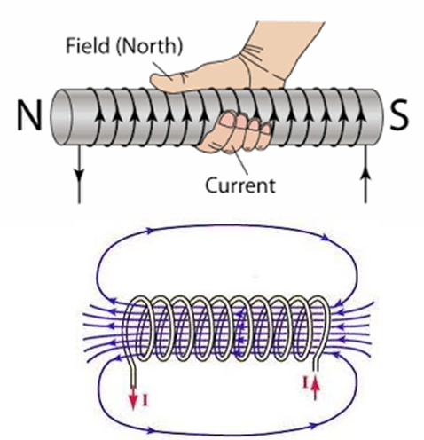

Fig. 11. The direction of the magnetic field of a solenoid.

The insertion of a ferromagnetic material into the core of the solenoid can increases the magnetic field significantly. With a ferromagnetic core, the magnitude of the magnetic field is given by

(4) 

where  is called the **magnetic permeability** and is the **relative magnetic permeability** .

The values for the relative permeability  are not constants for ferromagnetic materials but their values depend upon the magnetization history of the material. For iron core, the relative permeability could be in the order of 5000, so one can achieve very high magnetic fields with solenoids that have ferromagnetic cores.

|  |
| --- |
| **Example**  A thin 100 mm long solenoid is used as electromagnetic switch.  Explain how the solenoid can be used as switch?  What is the B-field near the centre of the solenoid when the current through the coils is 2.00 A and the coil has a total of 400 turns. An iron rod is inserted into the solenoid and the magnetic field was measured to be 12.0 T. What is the relative permeability of the iron rod? By what factor has the B-field been increased by using the iron core?  **Solution**  When a current passes through the solenoid, it can act as an electromagnet to attract a magnetic material and hence close a switch. When the current is stopped, the solenoid is no longer an electromagnet and the magnetic material of the switch is no longer attracted to the electromagnet and the switch will then be opened.    Magnetic field without iron core    Magnetic field with iron core |

**MAGNETIC FLUX Φ*B* [T.m-2]**

The **magnetic flux**  is a very useful physical quantity to define which relates to the number of magnetic field lines crossing an area. The magnetic flux  is defined by the integral



definition of magnetic flux

where  is a unit vector whose direction is at right angles to a small element with area as shown in figure 12. The magnetic flux  is simply the addition of the terms for each small area element.

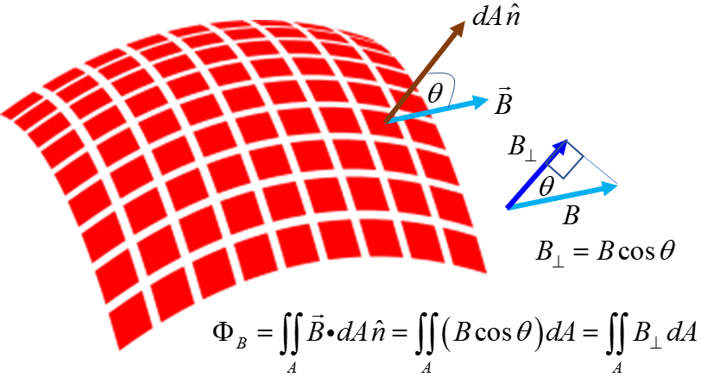

Fig. 12. Magnetic flux.

We will only consider the magnetic flux for the case when the magnetic field is constant as illustrated in figure 13.



Fig. 13. Magnetic flux  when the magnetic field  is uniform over an area *A*.

**Origin of magnetic effects**

Consider a charged particle **A** with its electric field surrounding it. Another charged **B** placed in this electric field will experience an electric force as described by Coulomb’s law. But what happens when the charge particle **A** moves. About 1880 the famous English scientist James Clerk Maxwell stated that the charge **B** was not instantaneous aware that charge **A** had moved but the change in the electric field due to **A** moving spreads out from **A** at the speed of light. The time required for the influence of the electric field to travel causes a time lag. This time lag for the charge to be travel or because one electric charge does not influence another instantaneously gives rise to the **magnetic force**. Thus, the force between two moving charges becomes dependent upon their speeds. At any instant of time, one charge is feeling the electric field of influence of the other, not where it is now, but where it was a short time before. Hence, all magnetic effects are simply electric effects.

**Permanent magnets**

A moving charge gives rise to a magnetic field. An electron is not a spinning or orbiting particle, but to account for the magnetism of materials it is useful to view the electron as a charged particle spinning as it orbits the nucleus. Every electron, because of its spin, is a small magnet. In most materials, the countless electrons have randomly oriented spins, leaving no magnetic effect on average. However, in a bar magnet many of the electron spins are aligned in the same direction, so they act cooperatively, creating a net magnetic field. In addition to the electron's intrinsic magnetic field, there is sometimes an additional magnetic field that results from the electron's orbital motion around the nucleus. This effect is analogous to how a current-carrying loop of wire generates a magnetic field. Ordinarily, the motion of the electrons is such that there is no average magnetic field from the material, but in certain conditions, the motion can line up to produce a measurable total magnetic field as in ferromagnetic materials such as iron.

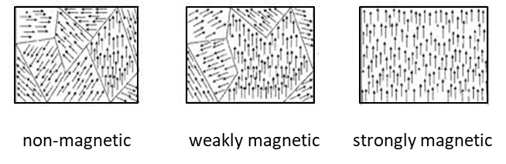

Fig. 14. A magnetic domain is a region within a magnetic material in which the magnetization is in a uniform direction (alignment of electron spins). This means that the individual magnetic moments of the atoms are aligned with one another and they point in the same direction. The magnetic domain structure is responsible for the magnetic behaviour of ferromagnetic materials like iron, nickel, cobalt and their alloys, and ferrimagnetic materials like ferrite.

[VISUAL PHYSICS ONLINE](http://www.physics.usyd.edu.au/teach_res/hsp/sp/spHome.htm)

If you have any feedback, comments, suggestions or corrections please email

ian.cooper@sydney.edu.au